Report on Certification course on “Applied Criminology and Criminal Psychology”
24th November- 14th December, 2021

Department of Law of Dr. Ambedkar College, Deeksha Bhoomi had organised a Fifteen days Certificate Course on “Applied Criminology and Criminal Psychology” a course approved by Department of Life Long Learning and Extension University Campus, RTMNU, Nagpur from 24th November- 14th December, 2021. The course got overwhelming response. The participants who were interested in this course were near about 110. But due to limited number of seats only 40 participants were allowed on first come first serve basis.
The erudite resource persons invited to deliver lectures on different topics for this course included the forensic experts, Professors, Medical practitioners and lawyers. It included the team of 14 resource persons which were Dr. Vivek Kirpekar, Dr. Syed Umarthathab, Dr.Shivalakshmi Arumugham, Dr Amrutha Karayil, Dr Pratima Lokhande, Adv. Vivek Awchat, Dr Devyani Sharma, Dr Ashish Badiye, Dr. Neeti Kapoor, Dr Bishwa Das, Mrs Vaishali Sukhdeve, Mrs Shilpa Rathod, Dr Hansi Bansal, Dr Atul Jaybhiye, Mrs Jyoti Minocha, Dr Tanushri Anchal, Dr. Paromita Chattoraj, Dr. R.N. Mangoli, Dr. R. Stalin.
On the FIRST DAY the virtual inauguration was done by. Dr Yogesh Deshpande, Professor and Head Depat of Humanities, VNIT Nagpur. He enlightened the students on the basic understanding of what is psychology and how it plays a pivotal role in committing the crimes. Sir has quoted various Sanskrit quotes relevant with the subject and explained its meaning too.
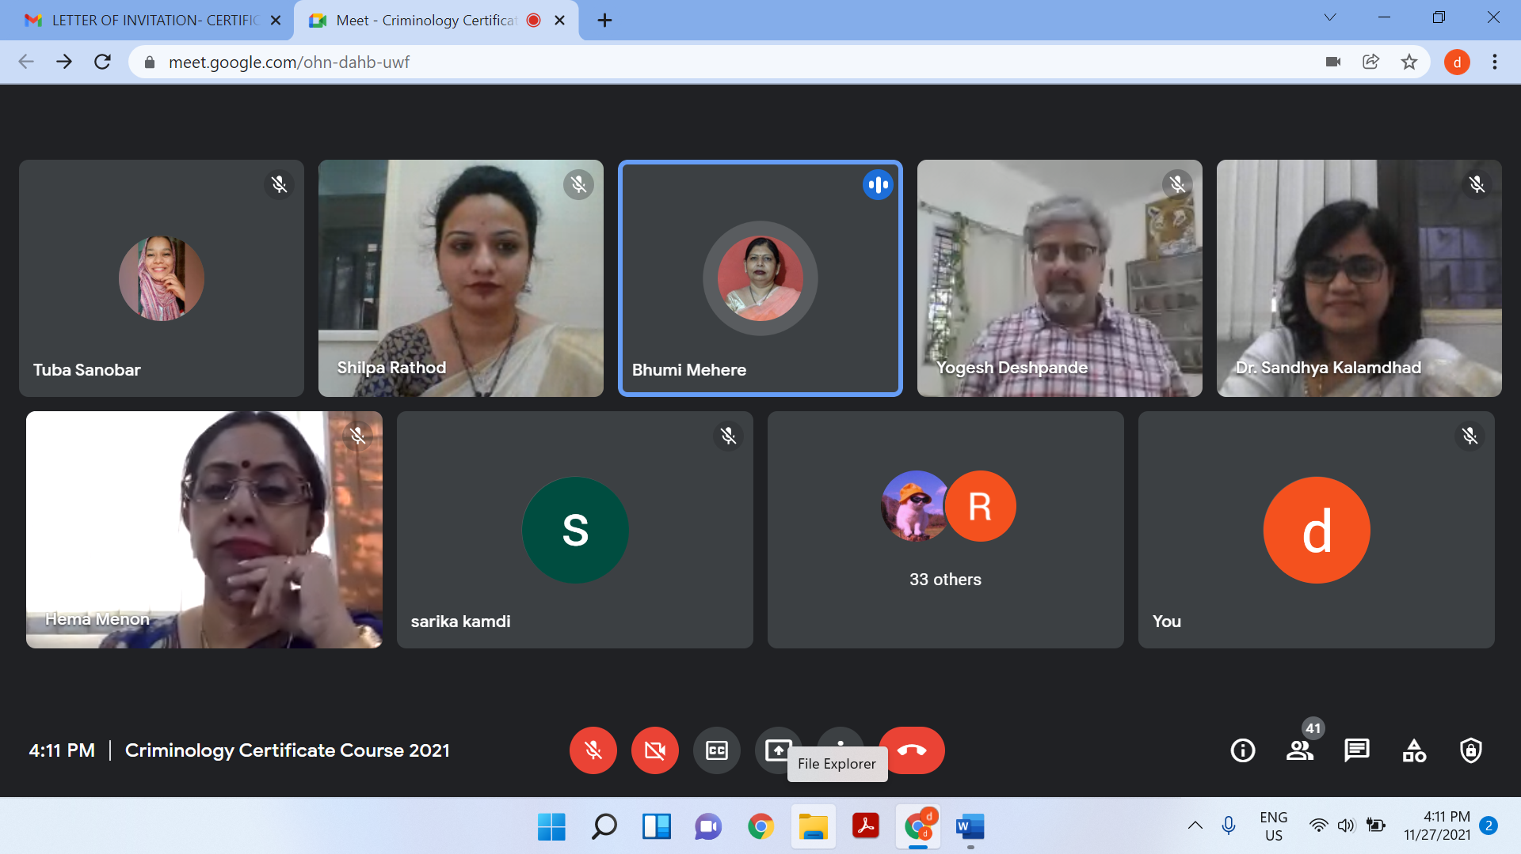
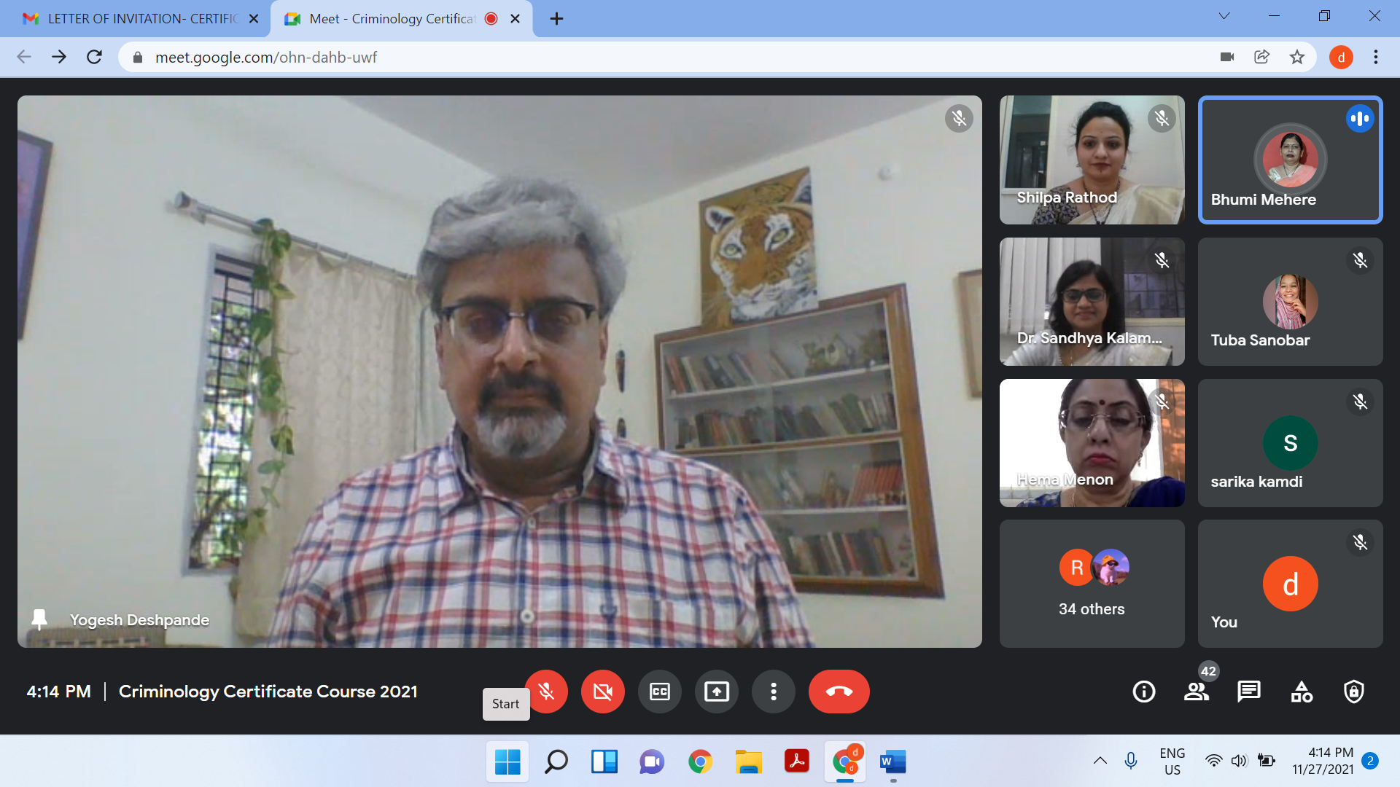
This inaugural session was followed by the lecture delivered by Dr Vivek Kirpekar, MD psychiatrics and professor, NKP Salve Institute of Medical Sciences, Nagpur who has delivered the lecture on introduction to criminal psychology and explained the relevant terminologies used in psychology, he has explained deception detection and other technique relevant to determine the psychological behaviour of offenders.
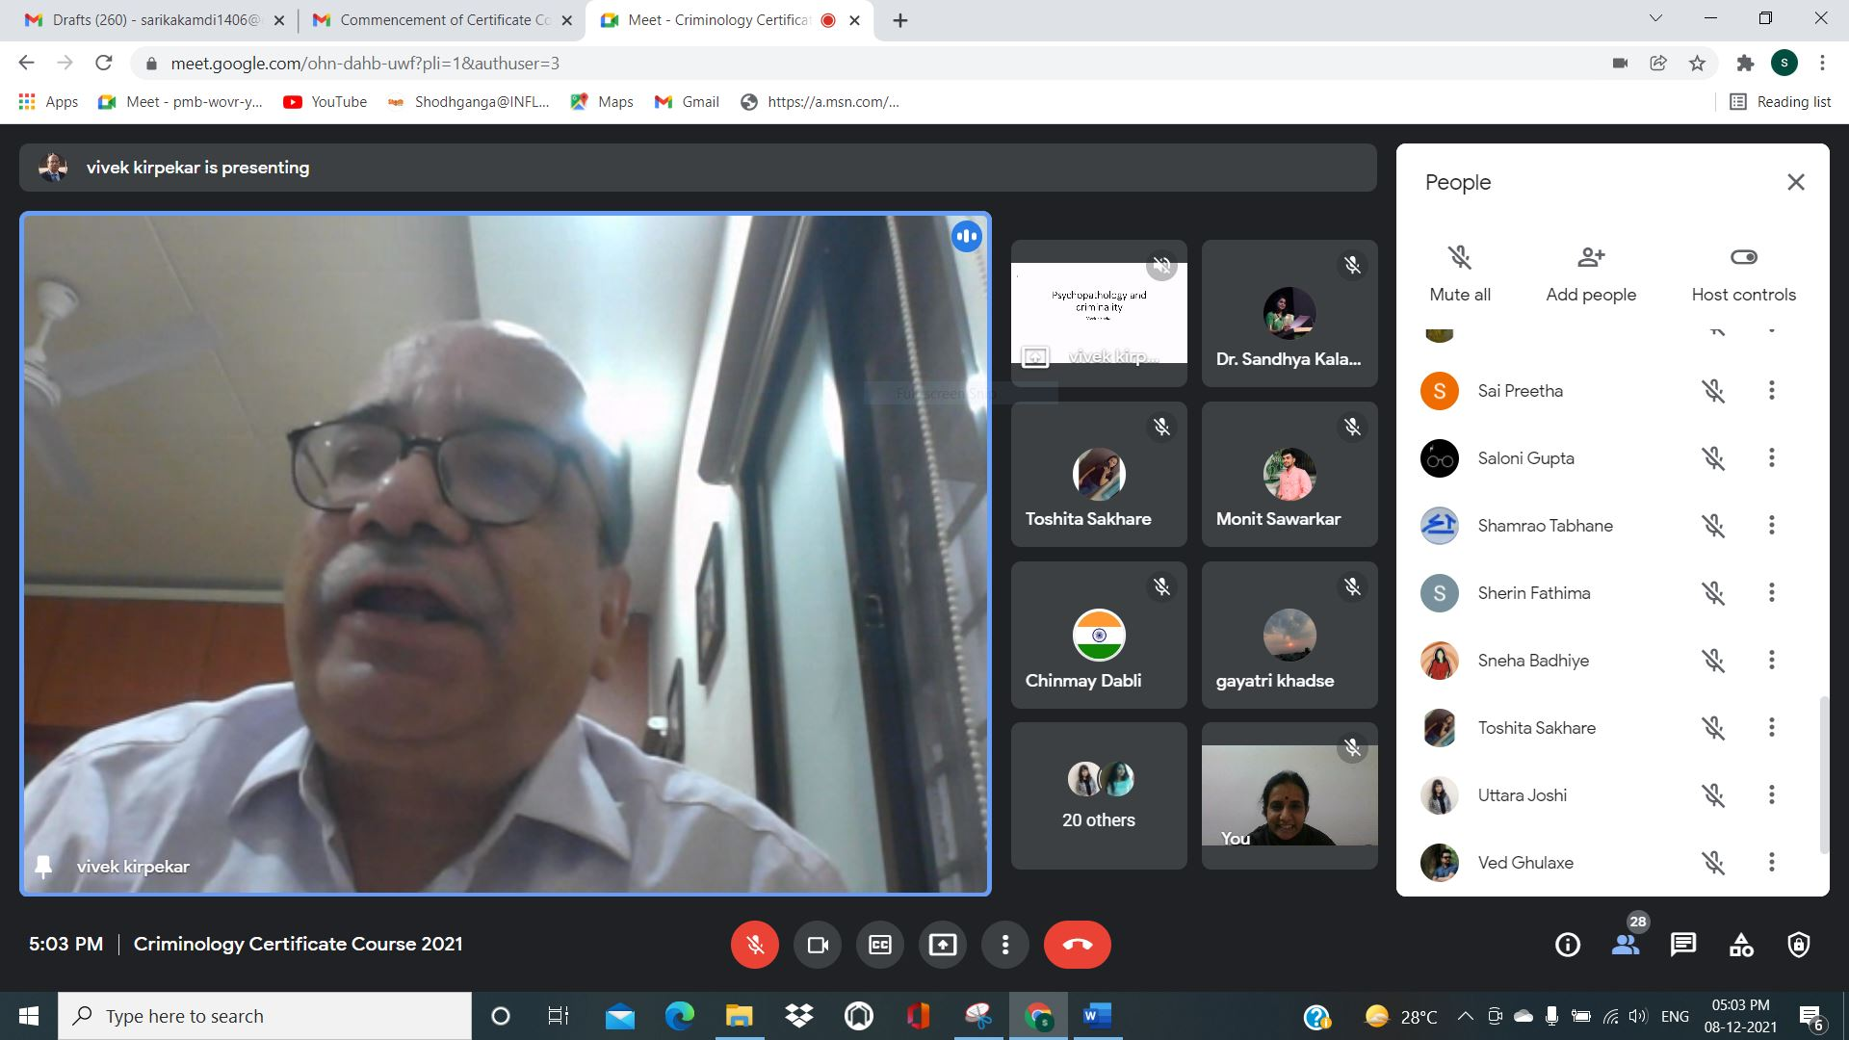

SECOND DAY sessions conducted by Mr Syed Umarhathab, Assistant Professor, Department of Criminology & Criminal Justice, M S University, Tamilnadu. He started his lecture by asking the student a very interesting question whether crime is dynamic or static? And explained the different components or elements of crime like men's rea, actus rea and factors that contribute to crime. In the second half that is the second session of the lecture discuss the relevance of criminology to contemporary society discussing all the basic dominance of criminology and the study of criminology also focused on how the study of criminology integrates knowledge from many fields and how it can be utilised in the present scenario you also discuss the various research priorities and their futuristic vision. taking in view the research priorities in criminology and how these studies are bridging the gap in research and practice with special focus on the role of correctional criminologist.
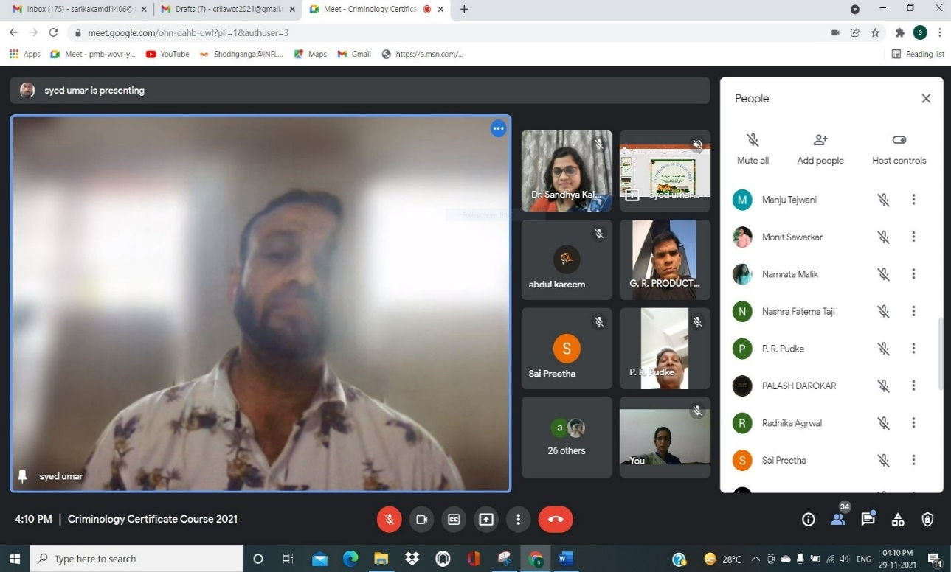

THIRD DAY first session was conducted by Dr Shiva Lakshmi Assistant professor in criminology, Rashtriya Raksha University, She delivered her lecture on personality traits of sex offenders wherein she covered personality trait ENP. Focusing on another aspect of personality traits N that is neuroticism which is characterized by high levels of negative effects such as depression and anxietyFocusing on another aspect of personality traits N that is neuroticism which is characterized by high levels of negative effects such as depression and anxiety. She also explained the characteristics of emotionally stable people and how their how did react in different circumstances she also talked about four quadrant that is stable extraverts, unstable extraverts, stable introverts and unstable introverts and the differences between them. The Third aspect which she discussed was about personality traits P psychoticism. She gave an in-depth insight into Eysenck's model of personality and also discussed the social desirability criteria. The Second session was conducted by Dr. Amrutha Karayal Head and Assistant Professor, Department of Criminology Dwaraka Doss Goverdhan Doss Vaishnav College, Chennai. She explained the historical background of the health act and what was the position in India before this act. She explained the health act 2017 in a most elaborative manner explaining the different provisions of the act. The main focus was on chapter V which consists of various rights of mentally ill persons.
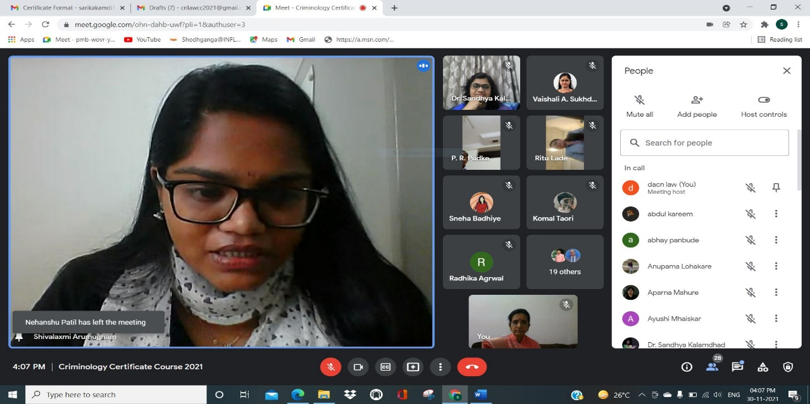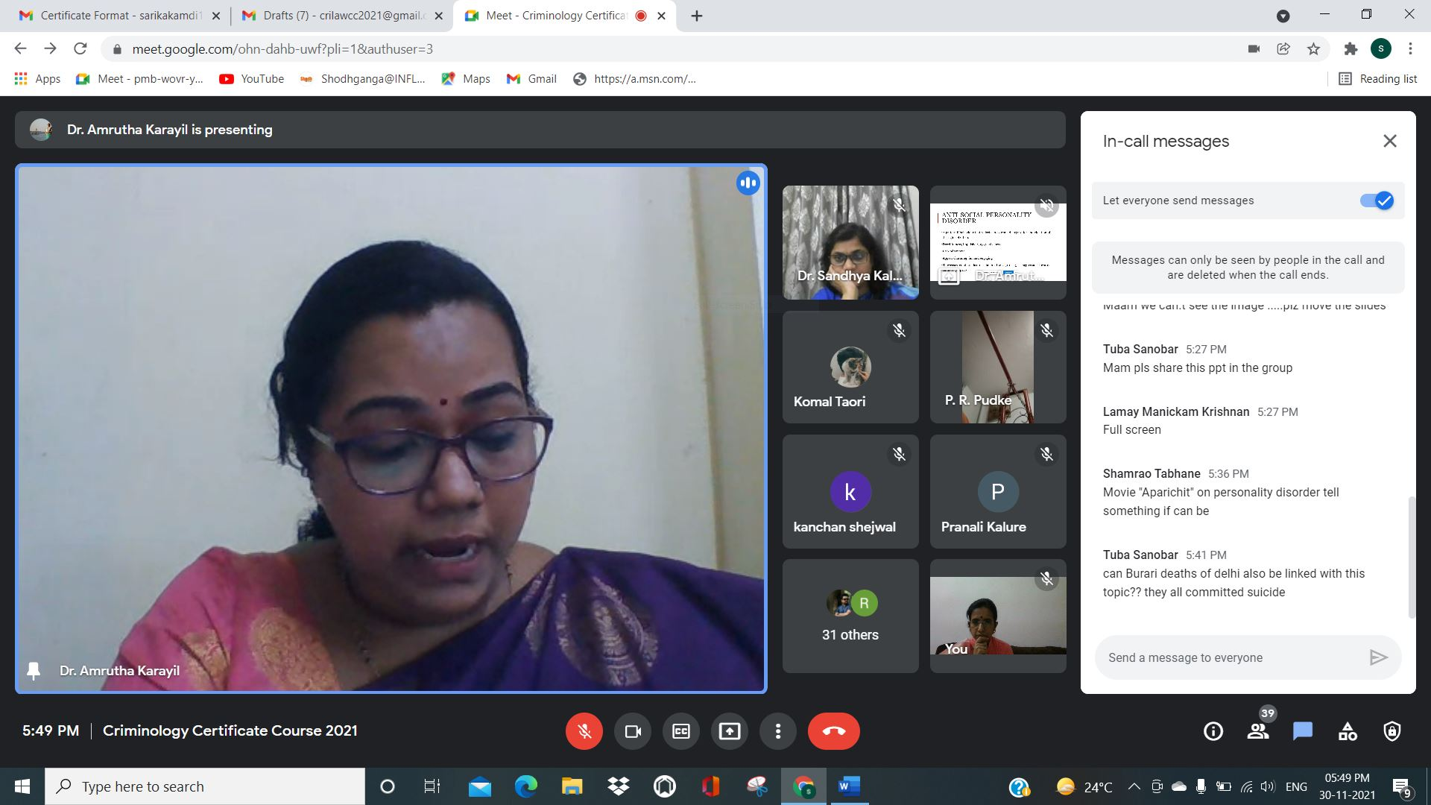

FOURTH DAY the first session was conducted by Dr. Pratima Lokhande, Asst prof DACN Nagpur on the topic “Role of Criminal Psychology in Criminology” She explained in detail the concept of how criminal psychology is related to scientific study of human behaviour by giving live examples. She enlightened the students by stating that Scientific study of human behaviour is the psychology and different factors are responsible for human behaviour and group behaviour. She enlightened the students by stating that Scientific study of human behaviour is the psychology and different factors are responsible for human behaviour and group behaviour. She also explained about branches of psychology i.e social psychology and Clinical psychology. The second session was conducted by Adv Vivek Awchat who has enlightened the participants, the use of forensic science and technology in criminal justice system and explained in detail the application of different scientific methods in civil cases as well as in investigation of crime by citing various live cases. He also focussed on how forensic science can be a two-way sword which may at times cut down the rights of accused as well as victim in certain circumstances. He also highlighted that Forensic may be ultimate science but ultimately it is the skill of Defence lawyer to convince the court about genuineness of forensic report.
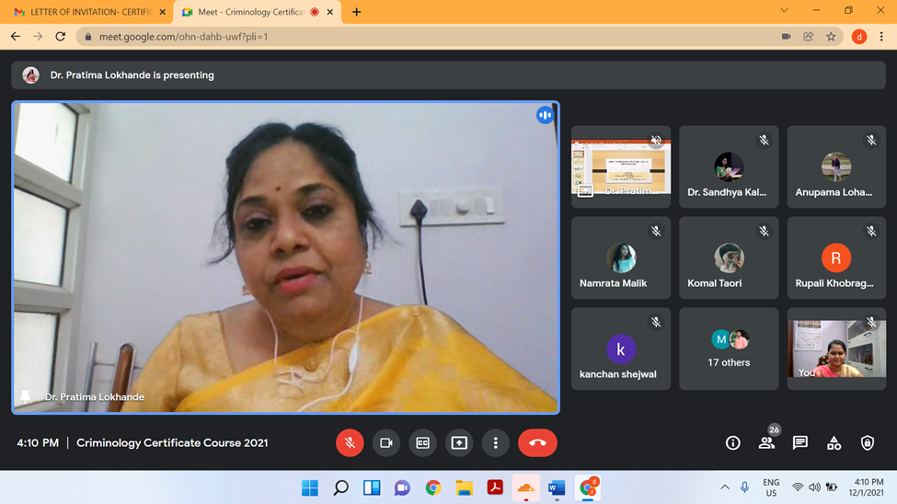
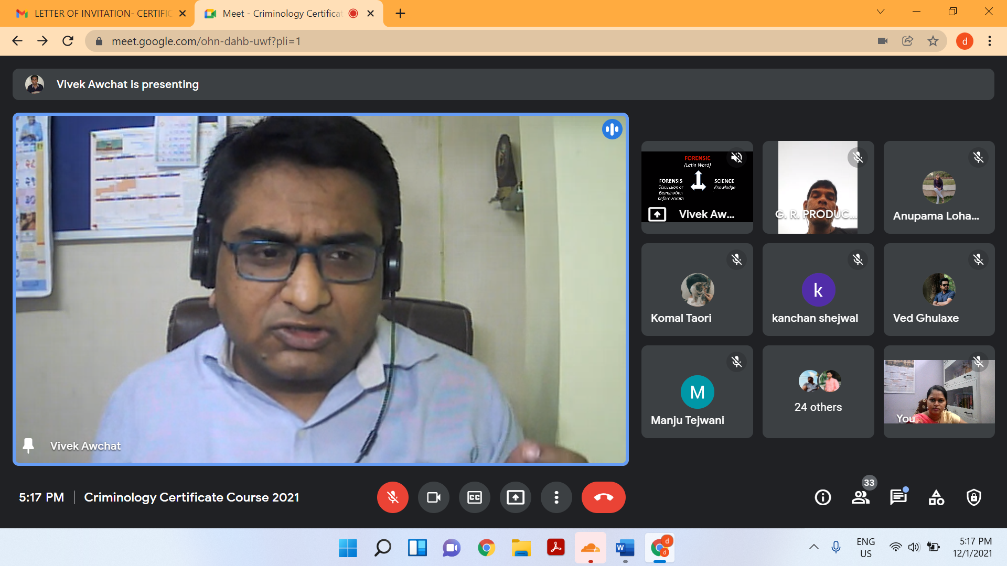

FIFTH DAY both sessions have delivered by Ms. Devyani Sharma, Assistant Professor, MNLU Nagpur conducted the session on topic “Application of Criminal Psychology in Criminal Justice System” wherein she focused on deception detection, misclassification error interrogation and also explained the significant stages in memory functioning for eye witness. She has illustratively explained the types of confessions and its evidentiary values of it as well.

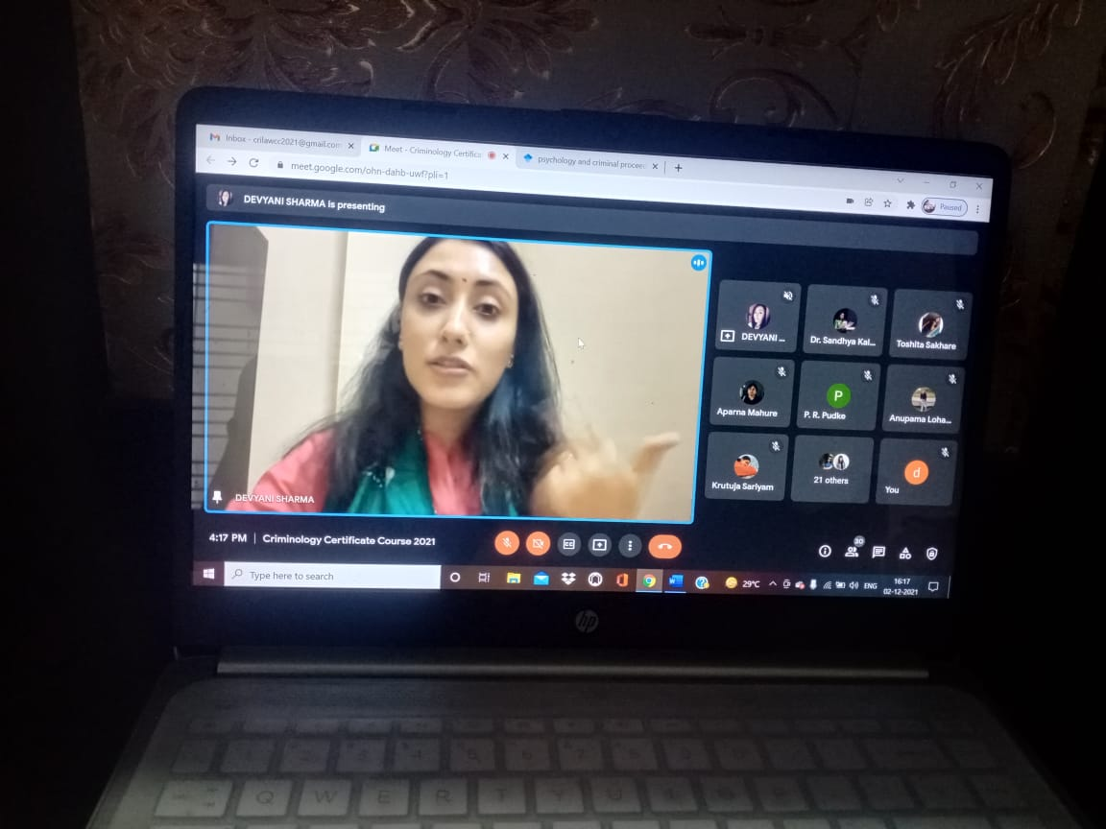

SIXTH DAY both sessions have conducted by Dr. Ashish Badhiye, Head and Assistant professor, Government Institute of Forensic Science, Nagpur conducted the session on the topic “Criminal Profiling: Merits and Demerits” wherein he has toughly explained the process of identifying the personality Traits, behavioral tendencies and demographic variables of an offenders based on the characteristic of crime. He further explained how profiling helpful in analyzing crime scene to determine the identity of perpetrator.
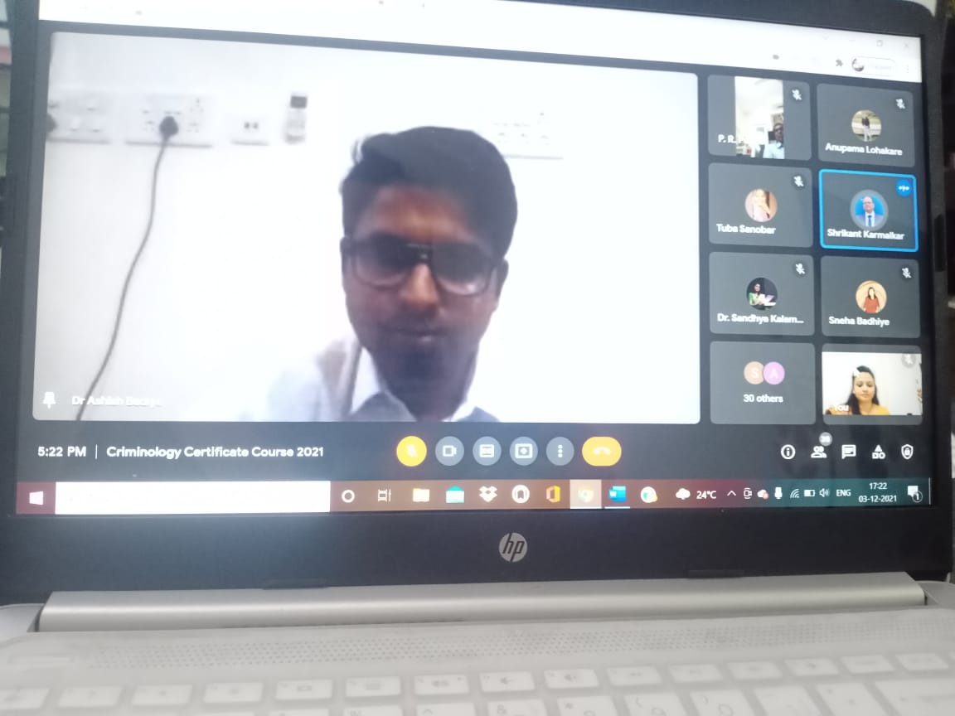
On SEVENTH DAY the first session was conducted by Dr.Neeti Kapoor an Assistant Professor, Government Institute of Forensic Science, Nagpur delivered lecture on the topic “Criminal Behaviour: Theories and concept” In her lecture she explained in detail theories on Criminal behaviour by citing various examples. She explained the different criminal principles by Lombroso, Ferri and Segmund Freud. She also laid emphasis on Elements of economic theory, Geographical theory, Anomie Theory, Labelling theory and social disintegration theory. The second session was conducted by Dr. Bishwa Kallyan Dash, Assistant Professor AT KIIT- (Kalinga Institute of Industrial Technology) School of Law delivered the lecture on Cybercrime: The Psychology of online offenders” where in he gave comprehensive explanation on different types of cybercrimes by giving live examples and emphasizing on theories relating to cyber-crime actions. He also laid emphasis on Cybercrime against persons and against State. He also focussed on cybercrime relating to promotion of warfare and economic offenses.
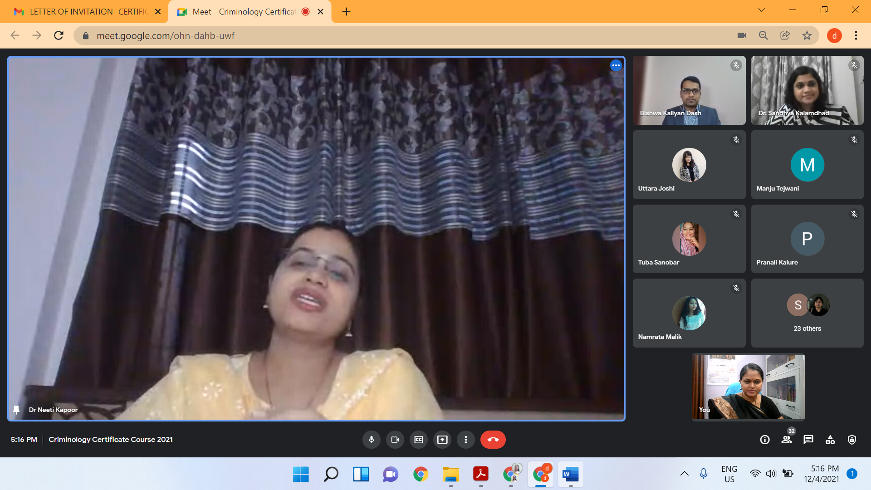
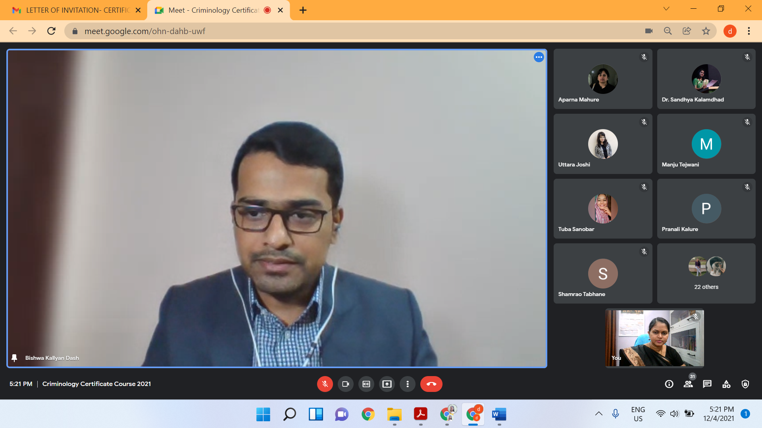

On EIGHTH DAY the first session was conducted by Mrs. Vaishali A. Sukhdeve on the topic “An insight into the use of Brain imaging, Polygraph test and Narco-analysis test in criminal investigation” In her lecture she superficially explained how are these three scientific tests are performed during crime investigation. She also emphasised on the legal implications on the use of these technologies elaborating the evidentiary admissibility of these tests in court of Law. The second session was conducted by Ms Shilpa Rathod on the Topic Role of Criminal psychologist in criminal proceedings wherein she has explained who is criminal psychologist and the different roles propounded by Lionel Harwads. She has further explained the eligibility for becoming criminal psychologist and laid the emphasis on the carrier opportunities for them.

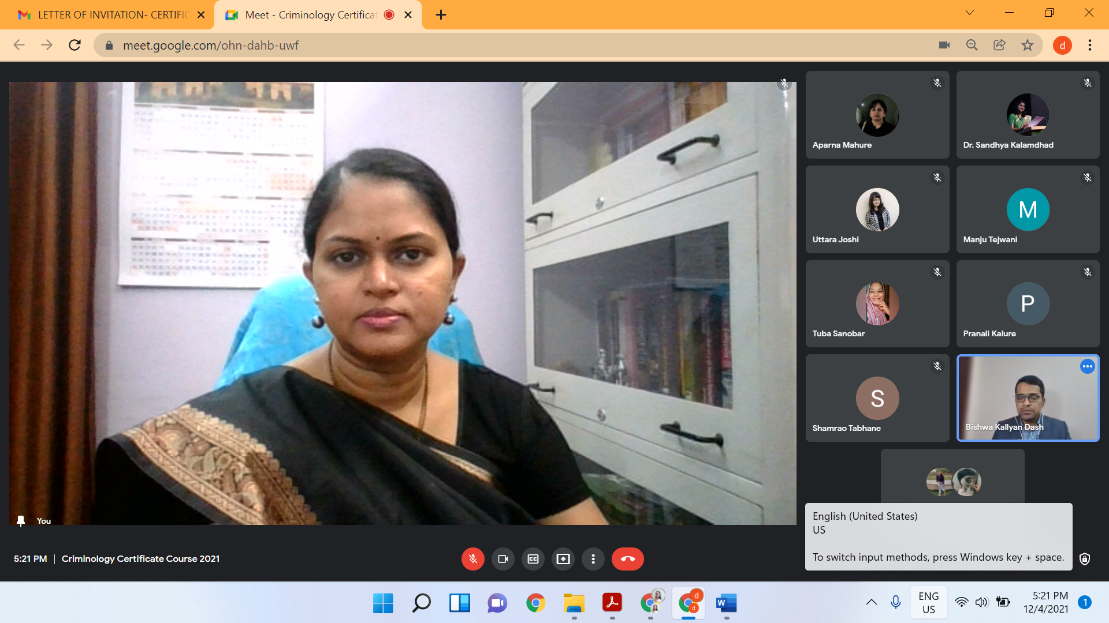

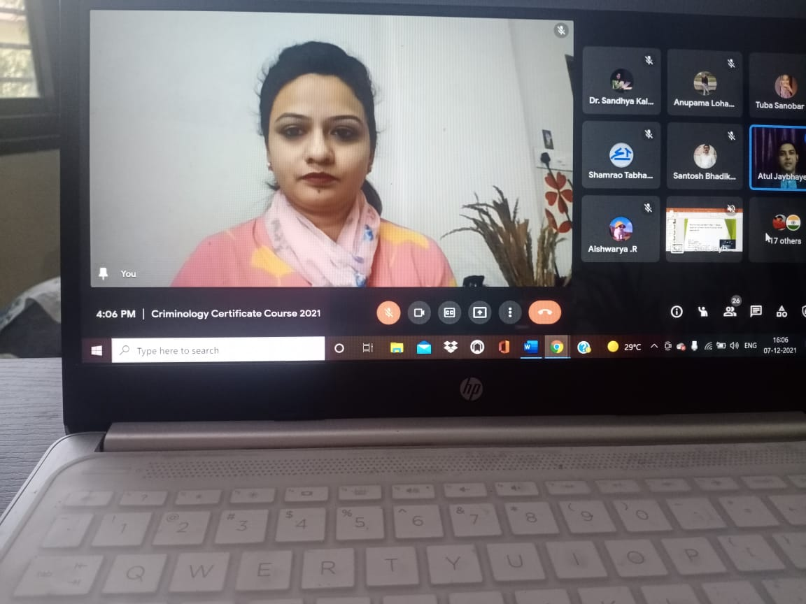

On NINTH DAY both sessions were conducted by Ms Hansi bansal Assistant Professor at Department of Forensic Science, Govt. Institute of Forensic Science, She gave Comprehensive explanation on importance of forensic psychology in crime investigation by giving live examples and emphasizing on the role of Forensic Psychologist in the investigation of crime, release of prisoners and even with respect to juvenile delinquents and focusing on relationship between psychology and law. In her speech she also mentioned that the assessment is done by forensic psychologist whether juvenile delinquents are suitable for rehabilitation and which correctional methods can be used for them. Recommendations of Forensic psychologists are taken into consideration for the release of prisoners taking into account the behaviour of prisoners.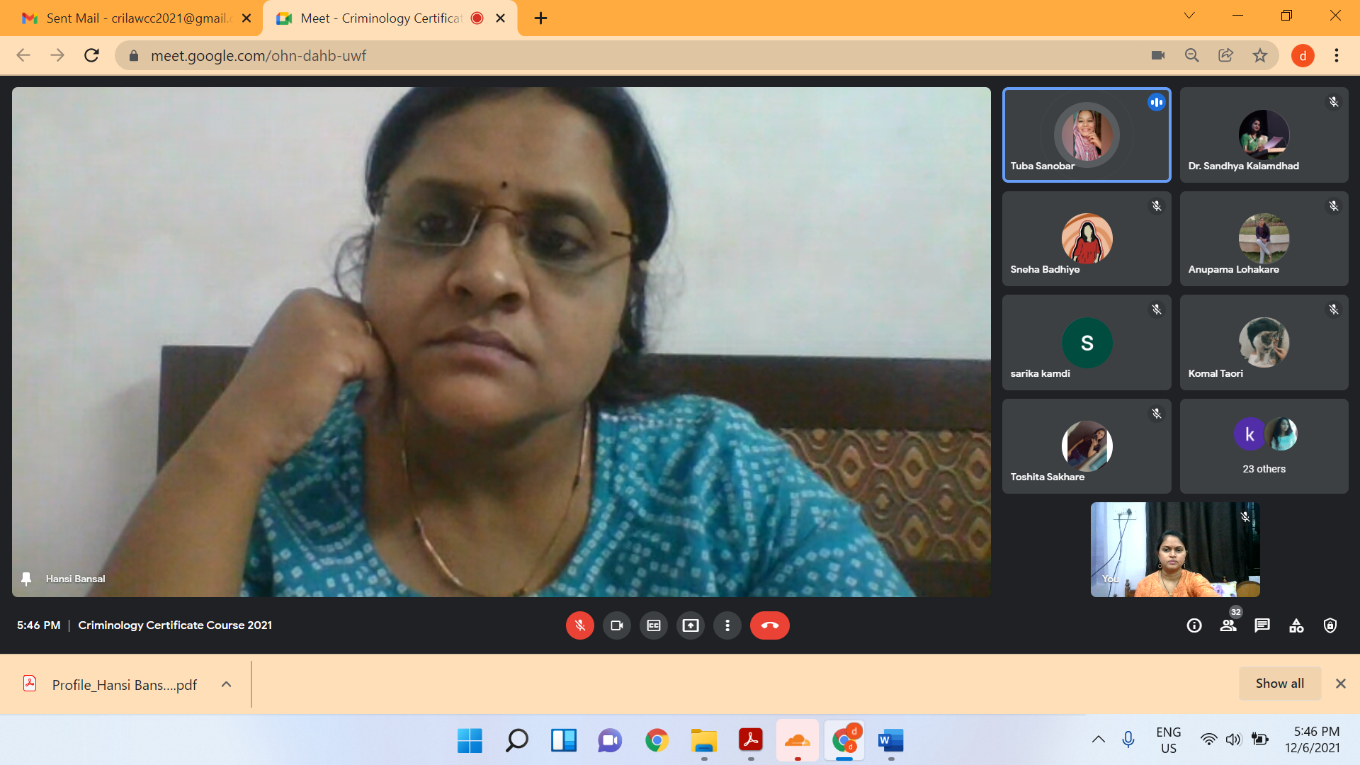

The first session of TENTH DAY was conducted by Dr. Atul Jaybhaye, Assistant Professor, HNLU Raipur, conducted the session on the topic “Cyber-crime against women and children amid pandemic” wherein he elaboratively explained the different types of cyber-crime against woman and children’s and the psychological factors Responsible behind committing these crimes. He has aptly explained the IPC provision and IT act as well. The second session was delivered by Dr. Jyoti Minocha, Assistant Professor KCLC College Mumbai has conducted the session on the topic “The psychology of violent female offender” wherein she has thrown ample light on violent female offender and psychology behind it. She has given the classic live examples of the lady gangsters who has involved in crime like Hasina Parker and many others.
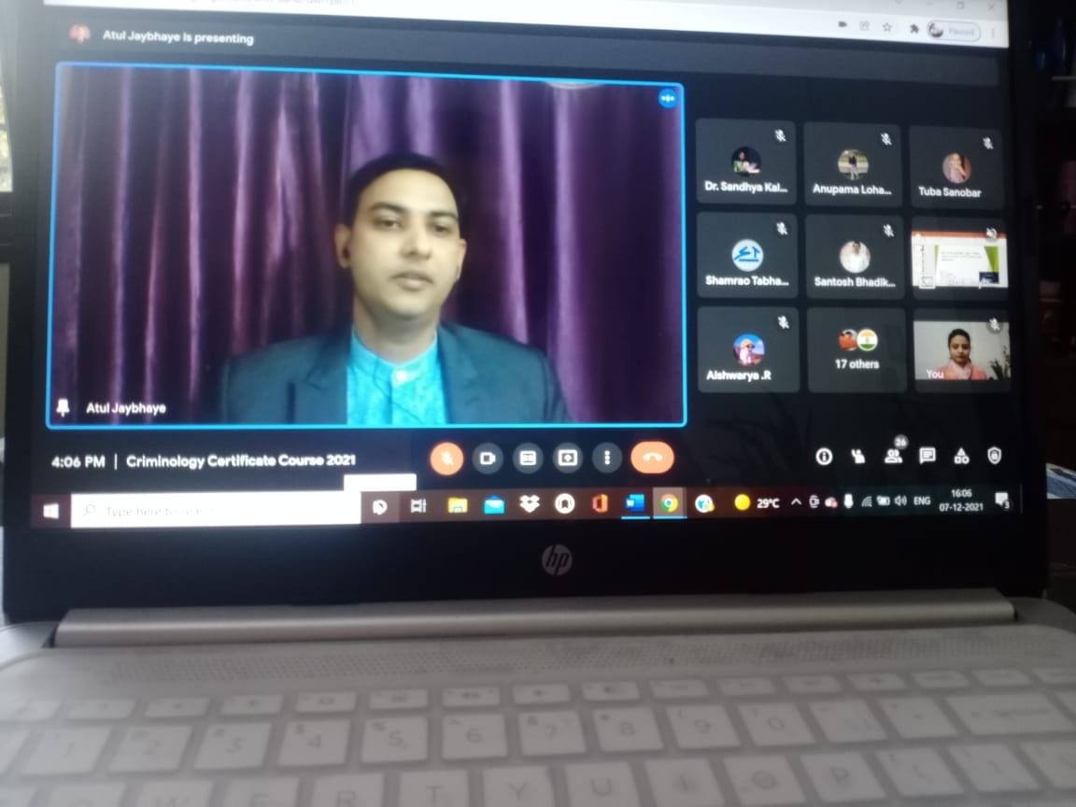
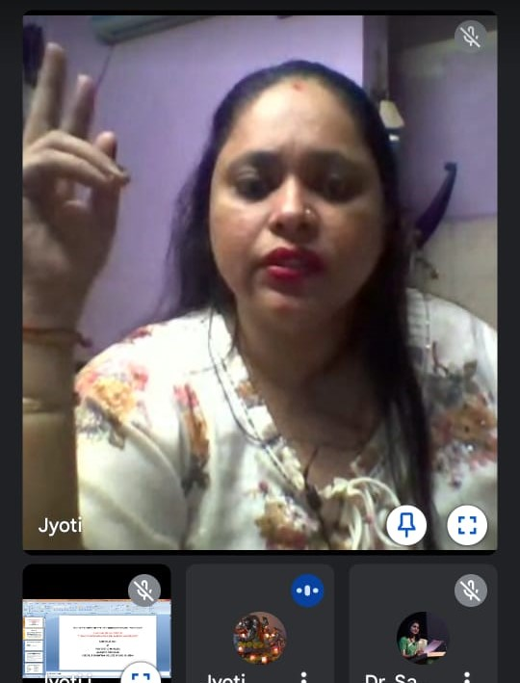

The first session of ELEVENTH DAY was delivered by, Ms. Tanushree Anchan on the topic “deliver the lecture on the topic the "psychodynamics of criminal behaviour. She focused on the understanding of criminal behaviour with all the four perspective that is legal moral social and psychological. She also explained the relationship of psychodynamics and serial offences types of serial Killers and their motives behind. The second session was held by Dr.Vivek Kirpekar on the topic the " psychopathology and criminality" in which he had focused on biological factors underpinning the condition including genetic and neuro development influences. He also discussed dynamic risk factor involved in criminality.
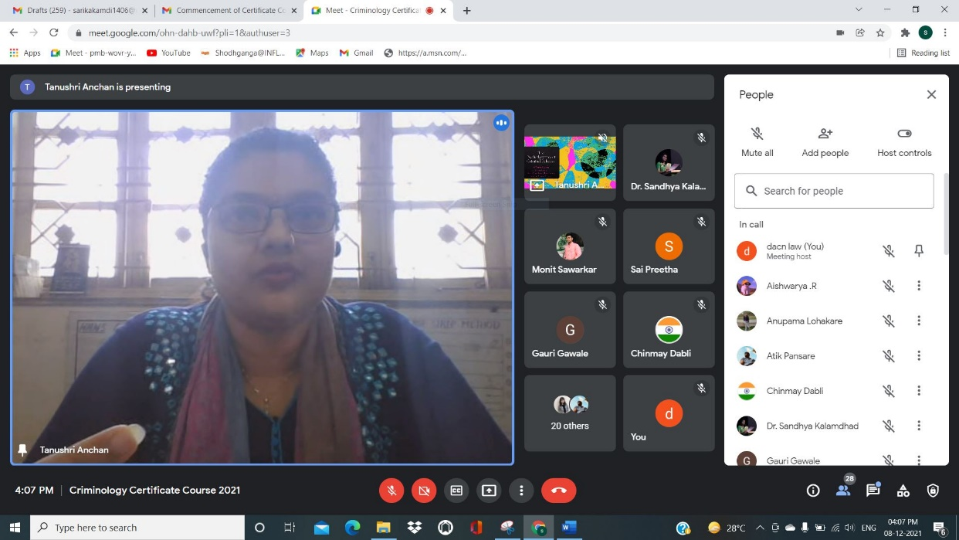

The both session of TWELFTH DAY were conducted by Dr. Paromita Chattoraj, Associate Professor of Law and dean , KIIT deemed to be University Bhubaneswar, India she has explained the different school of criminology propounded by erudite psychologists. She has aptly illustrated the relevance of all theories and its application. She has further enlightened the student on the topic of Psycho social impact of sexual violence from victimological perspective wherein she explained the factors affecting the mental health of Victim of sexual abuse. She has shared her own research outputs of her project in California.

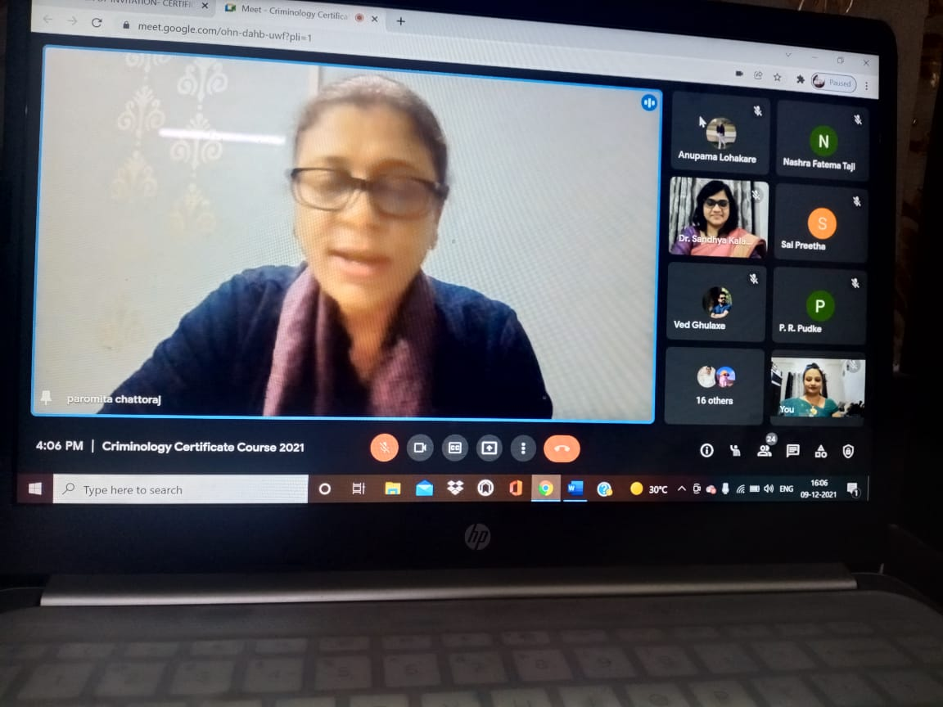

On THIRTEENTH DAY the both sessions were conducted by Dr. R Mangoli, Professor of Criminology, Rani Channamma University, Belagavi. he discussed the development of personality under three heads that is temperament, environment and character. he also explained the difference between criminal and normal personality and what are the probable cause of crime that are linked to personality development. He covered in detail the social learning theory citing the views of Gabriel Tarde, Edwin Sutherland, Robert Burgess and Akers. He also explained frustration induced criminality and how frustration and aggression are connected. He also focused on two most prominent psychopath test Psychopathy checklist revised PCL R test and psychopathic personality inventory PPL test that are used. “Criminal psychology and juvenile delinquency” in second session. In the 2nd session what exactly delinquency means. What are the causes of increase in Juvenile delinquency? how criminal psychologist can assist and understand motivations of juvenile offences and how to prevent Juvenile delinquency. And also explained the legal provisions related to Juvenile delinquent.

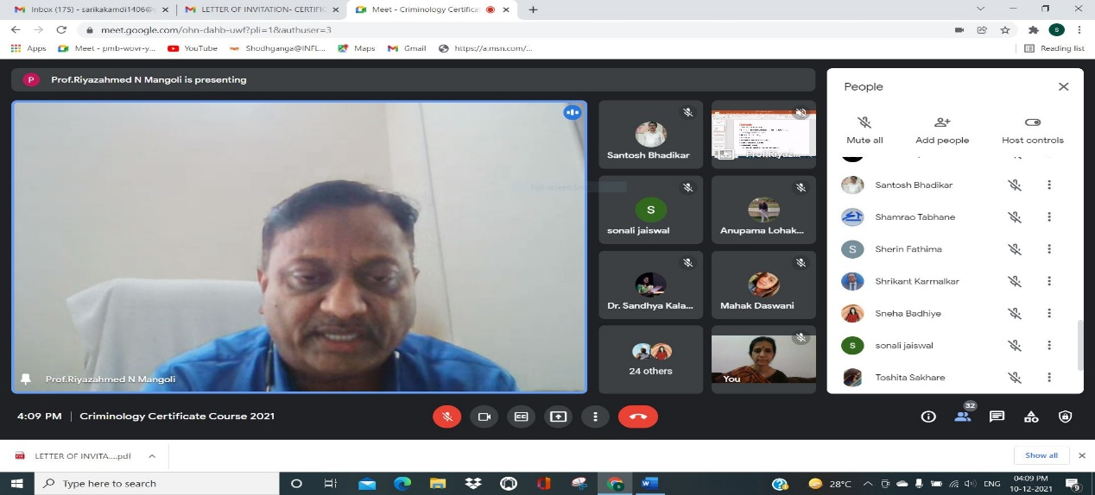

FOURTEENTH DAY both sessions were delivered by Dr Stalin Rengaswmy Assistant Professor MNLU Nagpur on the topics “Criminological research methods of offenders”. He enlightened the students on the selection of the research topic on offenders. He further laid the emphasis on various factors are responsible of offenders to study under research namely, cultural, economic, social, political, and educational. He has elaboratively explained each of them by taking the appropriate illustration with that regards. He has shared his personal experience of serving as a research associate in Tamilnadu Central Jail.

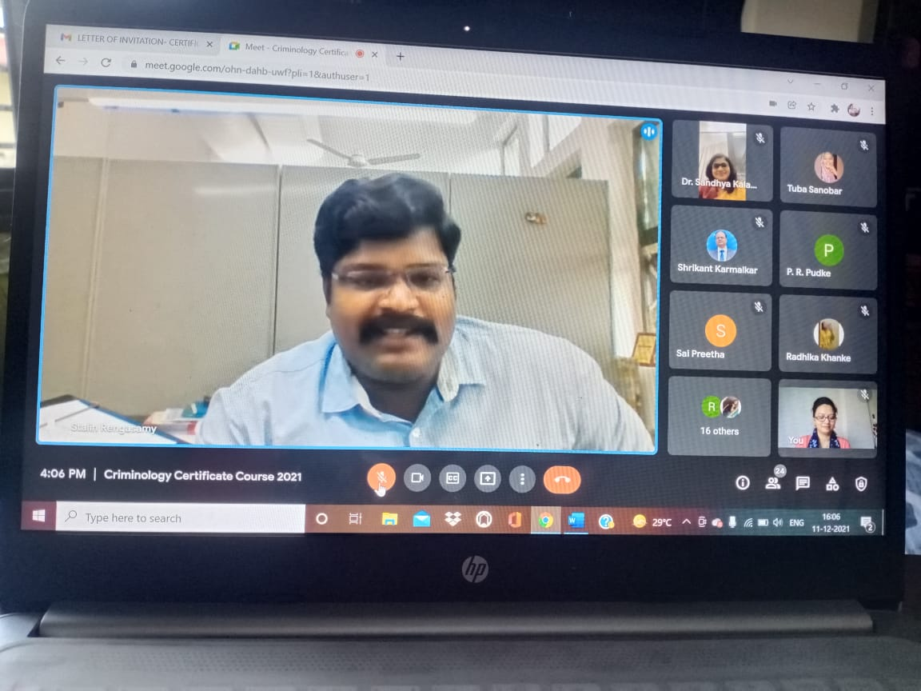

FIFTEENTH DAY one session were delivered by Dr Stalin Rengaswmy Assistant Professor MNLU Nagpur “Criminological research methods among juvenile offenders and victims” He enlightened the participants on factors considered in commission of crime like Social, Economic, political and other and illustratively explained the selection of areas of the research. He also aptly shared all the practical inputs of research. He explained in his last session different theories and types of victimization.

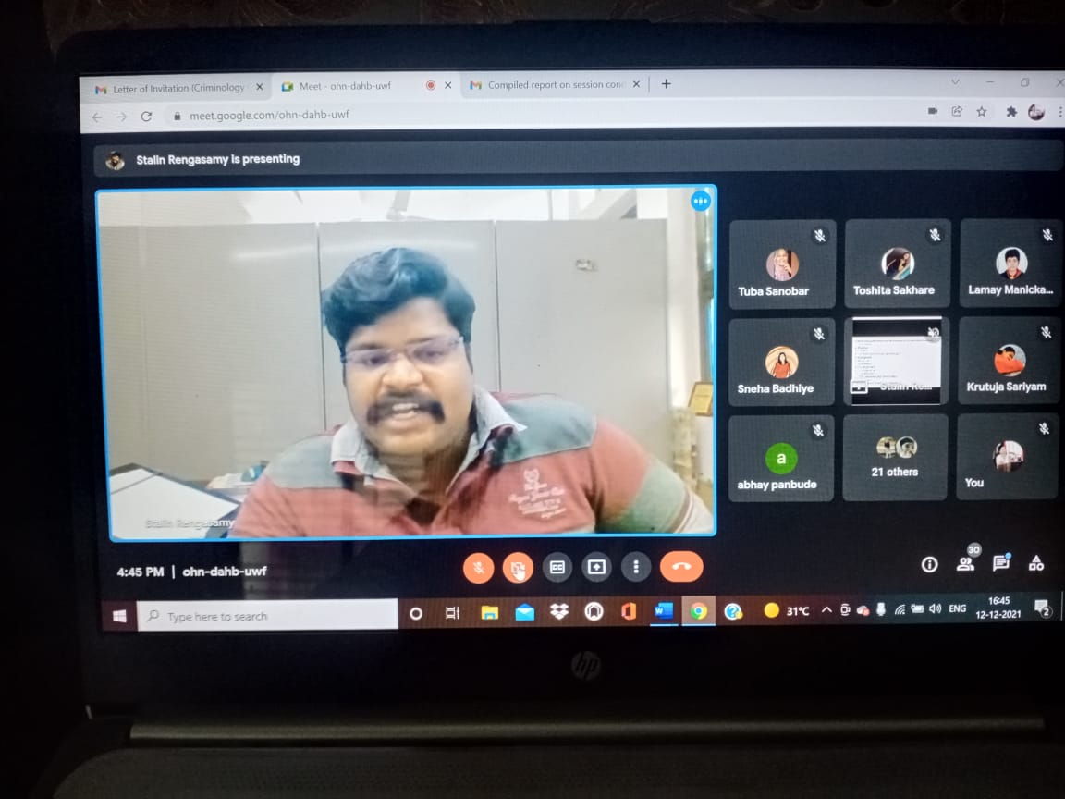

This Session was followed by Valedictory session wherein the rapporteur has read by Course Co-Ordinator Ms Shilpa Rathod. Dr. Mrs Hema Menon has given the presidential address to the participants. The participants then expressed their positive feedback on entire journey of the certificate course. Course Director Dr. Mrs Sandhya Kalamdhad presented the formal vote of thanks at the end.

